1-Minute Chocolate Peanut Butter Mug Cake

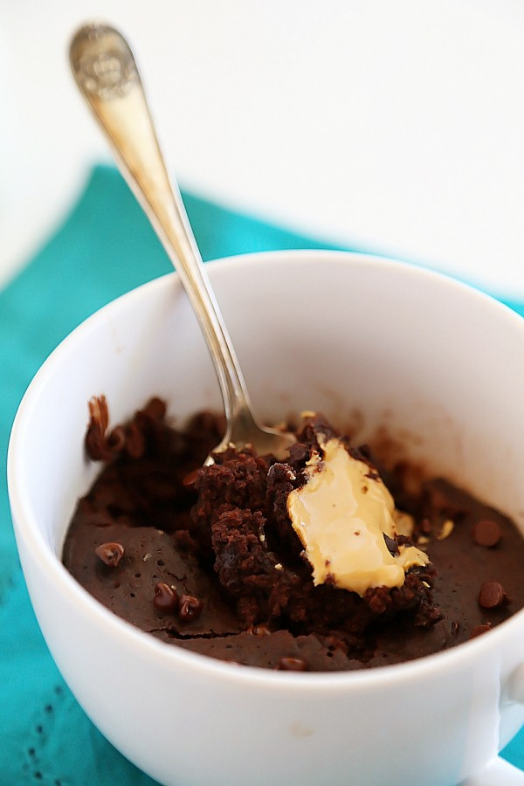
Ingredients:
1/4 cup all-purpose flour
2 Tablespoons unsweetened cocoa powder
¼ cup granulated sugar
1/4 teaspoon baking powder
1/4 cup milk
2 Tablespoons butter, melted
1 Tablespoon creamy peanut butter
1/4 teaspoon vanilla extract
1 Tablespoon mini chocolate chips

Directions:
In a small bowl or right inside the mug, whisk flour, cocoa powder, sugar and baking powder until completely combined. Whisk in milk, butter and vanilla until smooth. Fold in chocolate chips. Pour batter into a large microwave-safe mug.
Dollop peanut butter into center of mug, gently pressing down until even with top of batter. Microwave on high for 1 minute. Allow to cool for 1 minute before serving.

